# Slide 1

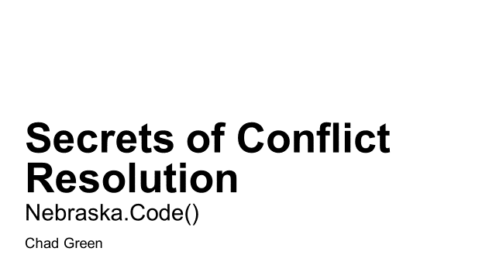

Hopefully everyone is having a great time so far here at Nebraska.Code(). Barney and Ken do an awesome job running this conference. Be sure while you are here to stop by every sponsor’s table and thank them for their sponsorship. A lot of times conference goers and conference organizers think of sponsors as a necessary evil; but I’ll tell you what, you will get a lot of good information out of these folks and your ticket would have definitely cost more without them.

Welcome to my talk about conflict resolution. Just to set expectations, the content in this talk is primarily focused more on project managers and other types of managers. But with that said, just about everyone will be able to take what I will be talking about here back to their teams and be better team members.

# Slide 2

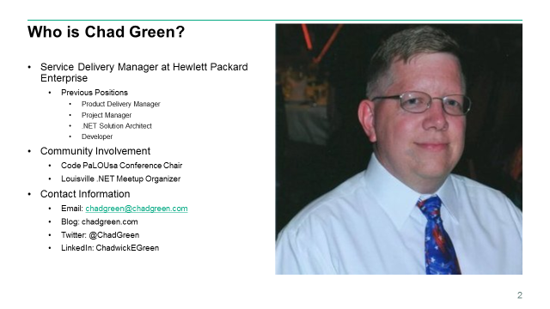

So first we have the obligatory bio slide; so just who am I. I work for Hewlett Packard Enterprise as the Service Delivery Manager for the United States Army Human Resource Command’s Cadet Support Program. Basically my primary responsibility is to ensure that my team of 32 contractors deliver high quality service to our customer. So along with ensuring our projects are delivered on time with a high level of quality, I’m responsible for ensuring my people are taken care of so they can deliver. My team is responsible for the development of software used by the Army Cadet Command which is better known as Army ROTC. We are a high-performing fast moving team supporting 7 different large products using .NET, Java, and PeopleSoft and work on over 50 software releases a year.

Obviously a team that large and doing that much work will have some conflict and I’m using my experience handling my team’s conflict to talk to you today.

Prior to my current position, I have worked as a Product Delivery Manager, Project Manager, .NET Solution Architect, and Developer. I also have had many projects where I wore multiple hats and in such have done a lot of business analysis, testing, and database and system administration work.

Along with all of that, I also run the Code PaLOUsa conference in Louisville, KY along with the Louisville .NET Meetup user group.

# Slide 3

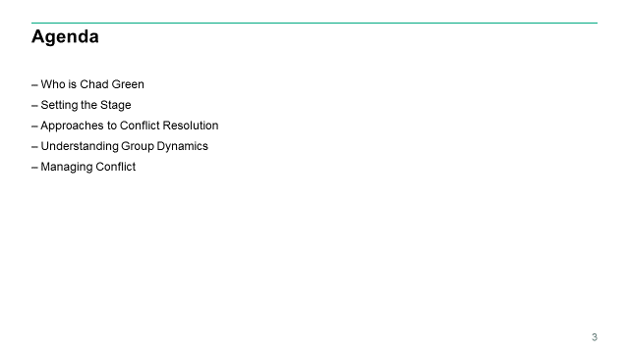

<CLICK> Here is what we are going to cover of the next hour. I just provided a quick overview of whom I am. Next we are going to set the stage by discussing the definitions, causes, and consequences of conflict. Then we will review the five primary approaches to conflict resolution and go through a quick understanding of the group dynamics typically found in conflicts. Finally we will look at 10 tips to make you a conflict resolution superstar before I conclude the presentation.

So, let’s get started.

# Slide 4

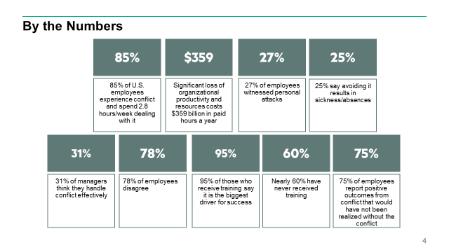

<CLICK> I’m a numbers guy. Saying something needs to be done or something is a problem is hard to quantify without the numbers to back you up. So let’s look at some key numbers surrounding the topic of conflict in the workplace. <CLICK>

I think it’s pretty rare to work in an organization where there is no conflict or strife. Surveys show us that 85% of U.S. employees have experience conflict and spend 2.8 hours per week dealing with it. This causes significant loss of organizational productivity ending up costing companies <CLICK> $359 billion a year in lost productivity.

Think about that for a second. Every year, companies lose $359 billion in productivity because employees have a hard time getting along. That represents 2% of the United States’ gross domestic product and would rank 31st in the International Monetary Fund’s list of countries by GDP. That is also more money than the bottom 70 countries produced in 2015.

But along with those numbers, <CLICK> 27% of employees witnessed personal attacks and <CLICK> 25% say avoiding conflict results in sickness and/or absences.

So I think that shows good evidence that we need to address conflict within the workplace.

Interestingly, <CLICK> 31% of managers think they handle conflict effectively while <CLICK> 78% of employees do not think their managers handle conflict effectively.

The silver cloud in all of surveys I was looking at was that <CLICK> 95% of those who receive training say it is the biggest driver for success. That means that there are ways to improve the situation, we just need to get people trained. And there is the rub as <CLICK>, nearly 60% have never received training. I do not find that very surprising. I work for a very large corporation and I have never received conflict management/resolution training from them.

One last number I want to share. I have shown that conflict costs companies lost productivity and there are associated costs with that conflict. But conflict is also a necessary evil and <CLICK> 75% of employees report positive outcomes from conflict that would have NOT been realized without the conflict.

Just think about it. Have you ever had a disagreement about what technology or implementation to use for a solution? Has that disagreement ever gotten a bit bitter and/or heated? Well that is conflict and it probably resulted in the group coming up with the right technology or implementation to use for that solution. So while we need to control conflict, some conflict is not only natural but needed.

# Slide 5

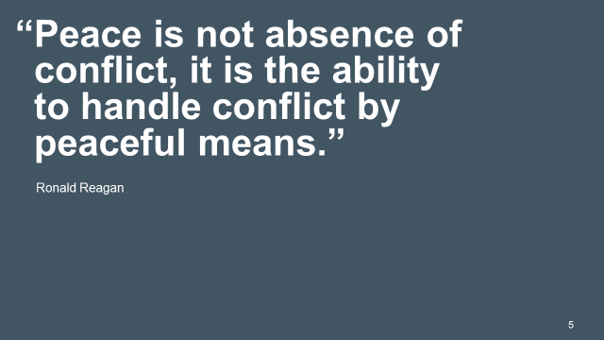

<CLICK> Ronald Reagan put it best when he said that, “Peace is not absence of conflict, it is the ability to handle conflict by peaceful means.”

And that is what we are going to talk about this hour – how to handle conflict within your team to produce quality results and still have a peaceful environment.

# Slide 6

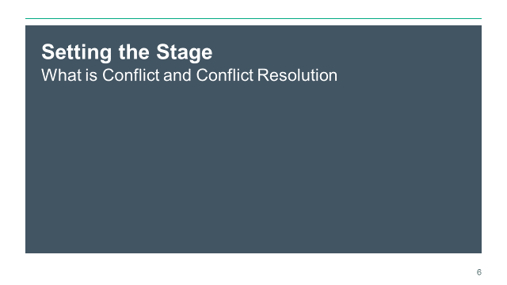

<CLICK> Before we can talk about ways to handle conflict, we need to set the stage and understand what we mean when we talk about conflict and conflict resolution. So let me provide some definitions and perspectives.

# Slide 7

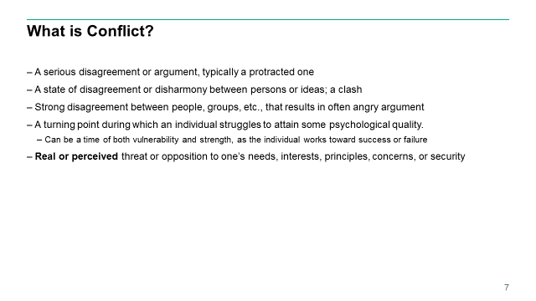

<CLICK> The Oxford Dictionary says that conflict is <CLICK> A serious disagreement or argument, typically a protected one. Now that is pretty straight forward and all encompassing, but what about something a little more closer to what we mean when talking about conflict resolution within the workplace.

Another good definition is from the American Heritage dictionary which say that conflict is, <CLICK> A state of disagreement or disharmony between persons or ideas; a clash.

Although, for pure definitions, I like Merriam-Webster’s simple definition, <CLICK> Strong disagreement between people, groups, etc. that results in often an angry argument.

We should also look at what psychology says. According to Erik Erikson’s theory of psychosocial development, a conflict is a turning point during which an individual struggles to attain some psychological quality. Sometimes referred to as a psychosocial crisis, this can be a time of both vulnerability and strength, as the individual works toward success or failure.

If we were to look at these definitions, I would come up with something just slightly more to the point in that conflict is <CLICK> a real or perceived threat or opposition to one’s needs, interests, principles, concerns, or security.

If we wanted to look at a real world example that is happening on development teams just like mine or yours, let’s take the hypothetical situation where your team is about to take on a new web application project. You have already decided that this project will use the MVC pattern but now the team needs to figure out which JavaScript MVC framework to use. One developer says you should using AngularJS while another says that Knockout is the way to go. But then the third developer, who just finished up a Telerik webcast, says that the team really needs to use Kendo UI. This should be an interesting conversation, but developers get religious when it comes to their programming languages and JavaScript frameworks.

# Slide 8

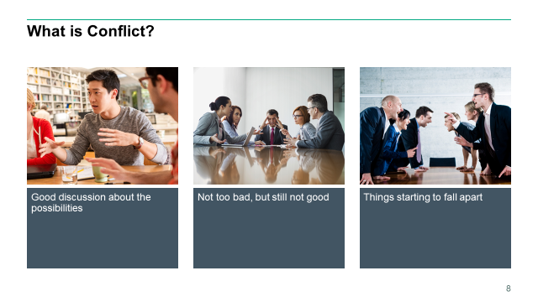

Now, hopefully; the team conversation is something like <CLICK> what is depicted in this picture. This is a good discussion about the possibilities. Hopefully as the project lead, tech leader, architect or whatever you will help this team come to a good conclusion by using useful conversation tools. By definition – especially the psychology definition – there is some conflict here, but this is very workable.

As I mentioned, developers can become religious about such topics and your team conversation might be more like <CLICK> this. Now this is not too bad, but too many meetings like this will wear down your team. It’s here where we can truly starting seeing conflict. You can see the poor guy in the middle thinking, “Oh my God, are we really going to do this again.”

Unfortunately, these conversations can get more heated and look like <CLICK> this. Here you can see where things are starting to fall apart; we have all probably be in a conversation that looked like this. Hopefully when you were in such a situation, someone was able to employ conflict resolution to get you back to the first image.

# Slide 9

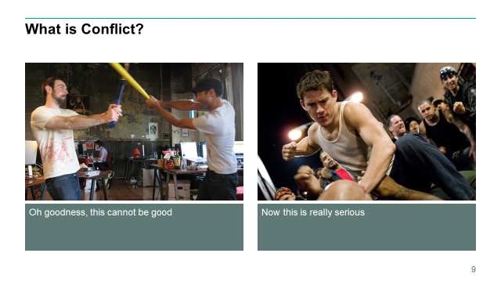

Now hopefully your team meeting do not come to <CLICK> this. Obviously things have gotten off the rails and even if someone is not physically hut, there will be deep wounds on the team.

Of course, I guess it could getting worse <CLICK>.

Now in all serious, you’ll probably never see much more than the images on the previous slide but not addressing conflict early could result in something more serious.

# Slide 10



Now before I continue, I have to point a couple of things I thought was interesting in axe versus bat picture. <CLICK> While I know that some development shops will have some alcohol ready for afterhours relaxation, but <CLICK> maybe keeping a bottle of Jameson at the desk is a bit counterproductive.

# Slide 11

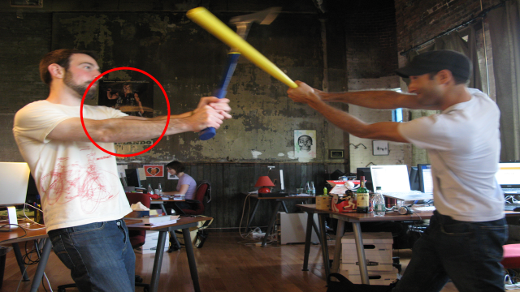

<CLICK> Also it’s pretty cool that there is a movie poster in the workspace and while I’m a big Schwarzenegger and have seen <CLICK> Commando way too many times, I’m just not sure what type of work environment the poster sets. The best part about the poster is that at the top it says, “Somewhere, somehow, someone’s going to pay.” Maybe that was just setting the tone for this little tiff.

# Slide 12

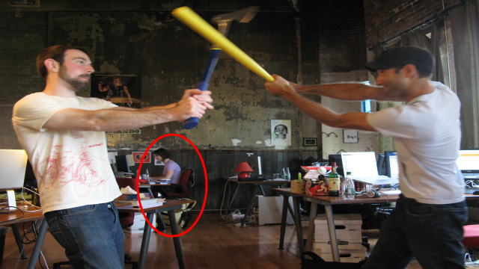

<CLICK> But the absolute best part about this picture is the <CLICK> woman in the back just coding along as these two defuses are going at it. Even better, if you magnify the picture you will see that she has a smile on her face.

# Slide 13

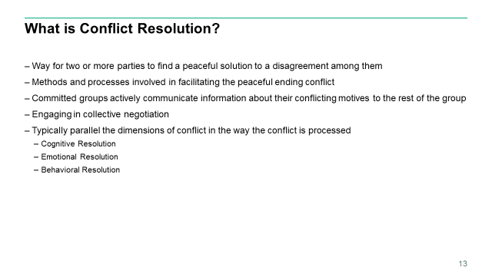

Now, let’s get back on point. <CLICK> As I was preparing for this presentation, I watched a TED talk with William Ury who is an author, academic, anthropologist, and negotiation expert and even co-founded the Harvard Program on Negotiation. He started his talk relating one of his favorite stores from the Middle East of a man who left to this three sons 17 camels. To the first son he left half of the camels, the second son he left a third of the camels, and to the youngest son he left a ninth of the camels. Well the three sons got into a negotiation and 17 camels doesn’t divide into two, it doesn’t divide by three, and it doesn’t divide by nine. Tempers started to getting strained, finally in desperation they went and they consulted a wise old woman. The wise old woman thought about their problem for some time and finally she said, well I don’t know if I can help you but at least if you want you can have my camel. So then they had 18 camels. The first son took his half; half of 18 is 9. The second son took his third; a third of 18 is 6. And the youngest soon took his ninth of 18, which is 2. You get seventeen, they had one camel left over and they gave it back to the wise old woman.

Now if you think about that story for moment, I think it resembles a lot of the difficult negotiations we get involved in. They start off like 17 camels with no way to resolve it, but somehow we need to step back from those situations – like that wise old woman – look at the situation through fresh eyes and come up with an 18th camel.

<CLICK> Conflict, arguments, and change are natural parts of our lives. <CLICK> Conflict resolution is a way for two or more parties to find a peaceful solution to a disagreement among them. Conflict resolution is the <CLICK> methods and processes involved in facilitating the peaceful ending of conflict. <CLICK> Committed group members attempt to resolve group conflict by actively communicating information about their conflicting motives or ideologies to the rest of the group, and <CLICK> by engaging in collective negotiation.

<CLICK>Dimensions of resolution typically parallel the dimensions of conflict in the way the conflict is processed. <CLICK> Cognitive resolution is the way disputants understand and view the conflict, with beliefs and perspectives and understandings and attitudes. <CLICK> Emotional resolution is in the way disputants feel about a conflict, the emotional energy. <CLICK> And, behavioral resolution is how one thinks the disputants act, their behavior.

# Slide 14

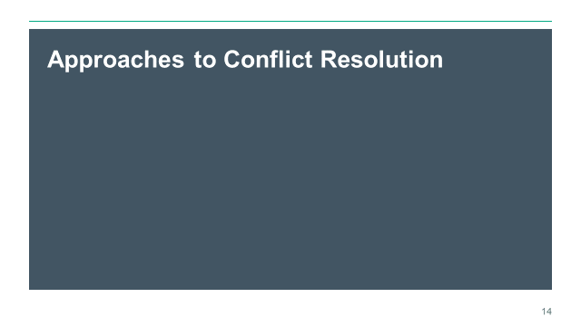

<CLICK> An appreciation of conflict resolution approaches is integral to understanding the communication process. While the names may differ slightly, there are five major responsive approaches to managing conflicts. There is no right or wrong conflict resolution approach, and each conflict participant is capable of choosing the approach they deem most appropriate in any given situation. In the workplace, a leader should understand each of these approaches to help parties resolve conflicts that arise on the job.

# Slide 15

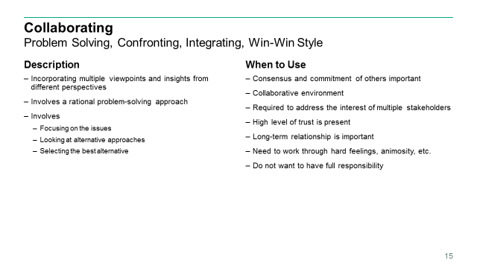

The first approach we are going to look at is Collaborating <CLICK>. Some other names for collaborating includes problem solving, confronting, integrating, or win-win.

<CLICK> PMI defines collaborating as incorporating multiple viewpoints and insights from different perspectives.

In this technique, the parties openly discuss differences and try to incorporate multiple viewpoints in order to lead to a consensus. <CLICK> This approach involves a rational problem-solving approach. <CLICK> More succinctly, this approach has disputing parties solve their differences by first focusing on the issues, then looking at alternative approaches, and finally selecting the best alternative.

This approach involves open and direct communication which should lead the way to solving the problem at hand. As such, this is considered to be a win-win approach.

So what are examples of when collaborating maybe appropriate? <CLICK> Really the whole point of collaboration is getting consensus with everyone, so obviously a good time to use collaboration is when consensus and commitment of the all the parties is important. If done correctly you will have a win-win solution as everyone will basically get what they need.

<CLICK> Probably pretty obvious is that collaborating is good to use when you work in a collaborative environment. If you work in an environment that facilitates and incorporates agreed upon participation by those in the environment to complete tasks, then Collaborating is obviously a good fit to solve conflicts.

<CLICK> If you need to address the interest of more than one stakeholder, then collaborating is going to be the way to go. Let me use a personal example. One of the products my team supports basically provides around 90% of the automation services for the Army ROTC organization as a whole. Its components have multiple divisions who has a stake in what that component does. Obviously we cannot just go in and put in logic that works for one division but not the other. If we put in logic to support the scholarship folks, you better believe it better not interfere with how the money folks pay for those tuition payments. As such, we are constantly collaborating with these different groups to ensure we build the right system that meets the needs of the different divisions.

<CLICK> To trust is to have faith in the honesty, integrity, reliability, and competence of another. Trust with each other is important in collaborating as each party needs to know that other parties have everyone’s best interest in hand. When dealing with conflicts, if the different parties involved have a high level of trust then collaborating will work well.

<CLICK> Hand in hand with trust is long-term relationships. You cannot have long-term relationships without trust. Collaborating helps continue trust between parties and that is why it is a good approach when the long-term relationship is important.

<CLICK> You can have a group of folks that have been working together for a while and so there is trust present, but a situation has brought out some hard feelings or animosity. Because collaborating involves focusing on the issues TOGETHER and selecting the best alternative TOGETHER, it is a good approach when there are hard feelings because it will help those involved get away from the feelings and come up with a solution TOGETHER.

Another good time to use collaborating is when you <CLICK> do not want to have full responsibility. If you are the project manager in there working with two groups of developers helping them come with the correct solution you probably want to be a little separated from the responsibility of coming up with the right solution. You have your developers because they have the know how to get things done and helping them collaborate to a solution will give them the responsibility of that outcome.

# Slide 16

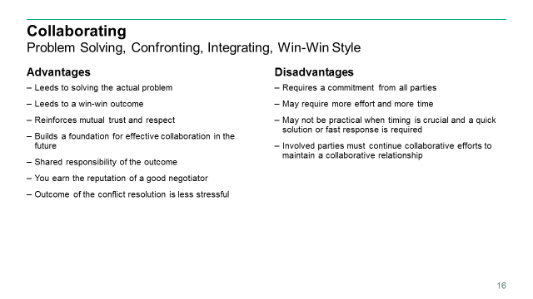

So now that we have looked at when is a good time to use the collaborating approach, <CLICK> let’s look as some of its advantages

First and foremost, the collaborating approach <CLICK> leads to solving the actual problem. You are discussing what the issue is and alternatives to the solution which, by doing so, will allow you to solve the actual problem at hand. As you will see with some of the other approaches, you are not necessarily solving the problem that caused the conflict.

Because you are getting all sides to agree with the solution, you get a <CLICK> win-win outcome. This helps people feel good about what just transpired as they having gotten at least something that they wanted or needed.

And because all sides work TOGETHER to come up with a solution, the collaborating approach <CLICK> promotes mutual trust and respect amongst the different parties.

<CLICK> When talking about when it is a good time to use collaboration, I said that it helps when the facilitator does not want does not want to have full responsibility. As such, there is an advantage because the different parties involved are equally responsible for the outcome. Because it is a win-win style of approach, all parties involved are happy with the results.

<CLICK> As the one moderating the involved parties to come to a solution, you will by default get the reputation of a good negotiator and by human nature that is a something we want. We naturally want to help others and that is how those involved will feel.

Finally; <CLICK> as a general rule, the outcome of the conflict will be less stressful. Because the parties are all involved in finding a solution, there is incentive to do so with little conflict so people will feel better at the end and as such there will be less stress.

Now with anything else, where there are advantages there are <CLICK> disadvantages. Some of those with collaborating include that it requires <CLICK> a commitment from all the parties. Look, there is absolutely no way collaborating works without everyone wanting it to work. As such, everyone involved has to be committed to finding the right solution. While in a perfect world that would be always the case, we do not live in a perfect world.

Kind of tied with that, <CLICK> collaborating may require more time and effort than some of the other conflict resolution approaches. Again, to do this right, you need to review the issue and then look at the alternative solutions. That takes time. Maybe time you just do not have.

As such, collaborating may not <CLICK> be practical when timing is crucial. If you are managing an electronic commerce application and you have a system outage 2 hours before your massive online Black Friday sale, you do not necessarily have the time to consider all the sides on how to fix an issue when there is disagreement on how to fix that issue. Situations like this will probably require one of the other approaches.

Finally, <CLICK> collaborating requires that the involved parties must continue collaborative efforts to maintain a collaborative relationship. Why is this a caveat; well as I mentioned, collaborating requires a good time commitment which can be hard to keep up on a day-in/day-out basis.

# Slide 17

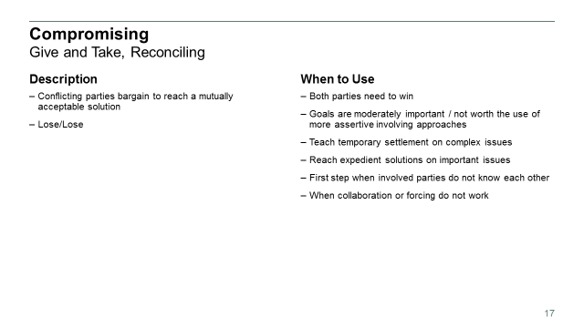

<CLICK> Next we have the Compromising approach. This is also referred to as a “give and take” approach or reconciling. <CLICK> With this approach, conflicting parties bargain to reach a mutually acceptable solution. Both parties give up something in order to reach a decision and leave with some degree of satisfaction. <CLICK> This is considered a lose-lose situation, since no party gets everything.

<CLICK> So why would you use it, well because sometimes a lose-lose situation is what the doctor calls for. But if sold right, this can look as if <CLICK> both parties win and there are times where that is just the case. A simple situation might be the customer wants a deliverable within 2 weeks but you know it’s going to take 4 weeks to deliver everything they want. You get your customer to agree to reduce the scope to what is truly needed and your team agrees to work some extended hours to get the work done in three weeks. Both parties “won” even if there are concessions made on both sides.

Another reason to use the compromising approach would be when <CLICK> the goals are only moderately important and not worth the use of a more assertive or more involving approaches, such as forcing or collaborating. Basically if the end goal only moderately matters, why go through the effort and cost of the more involved approaches. Basically look at the cost benefit. Does it make sense to spend a week negotiating the collaboration approach on a goal that will only take a day or two?

Related, <CLICK> maybe you need an expedient solution on a complex issue where again you just do not have the time to do a more elaborate approach. Think back when I talked about the e-commerce example with a problem right before a major Black Friday sales effort. Obviously in that case you just need to come up with a quick solution so your company stays in business.

Also thinking back to the talk about the Collaborating approach, you will remember I talked about how trust was important and it could be used when trust was there. Well what if trust isn’t there yet. <CLICK> Compromising is a good approach as first step when the involved parties do not know each other well or have not yet developed a high level of mutual trust.

And the last example of when to use the Compromising approach is when <CLICK> collaboration or forcing do not work. Sure enough, these conflict resolution approaches sometimes will fail. So maybe you tried to use the collaboration approach and the opposing parties just cannot come to a mutual decision, then you probably should look at using the compromising approach.

# Slide 18

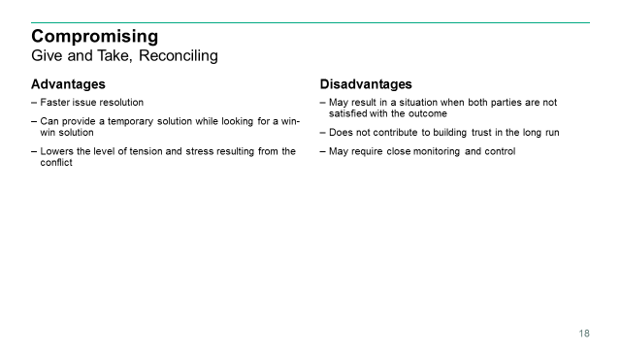

<CLICK> So what are the advantages to using the compromising approach. Well first off, it generally will <CLICK> generate a faster resolution to your issue. Because you are not looking at the root of the issues and doing analysis like you would with collaboration, this approach will produce faster results than some of the other approaches.

Another advantage is that it <CLICK> can provide a temporary solution while looking for a win-win solution. Maybe you have a complicated issue on hand and all parties involved are committed to collaborating to get the best solution, but that takes time and you need something in the meantime. Well then compromising can meet your needs in the immediate timeframe.

A third advantage is that it <CLICK> lowers the level of tension and stress resulting from the conflict. Because you can generally come to a compromise pretty quickly – at least compared to some other resolution approaches – this will help reduce the stress around the room. But this actually plays into my first disadvantage.

<CLICK> Using the compromise approach may result in situation when both parties are not satisfied with the outcome – it’s a lose-lose situation basically. What you will see from time to time is that the different groups are happy and relieved at first because the situation has been resolved, but then they realized what they gave up – or what they lost as part of the compromise. Usually that not too bad, but sometimes it can make things much worse.

Along with that, <CLICK> using the compromise approach does not contribute to building trust in the long run. Both sides will have a tendency to think they gave up too much and so trust is not built up as they might think the other side was trying to get the better of them.

Finally, the compromising approach <CLICK> may require close monitoring and control to ensure the agreements are met. Since the different sides had to give in, they might not meet all of conditions of the compromise. So as the facilitator, you are going to have to keep a close watch on what is going on.

# Slide 19

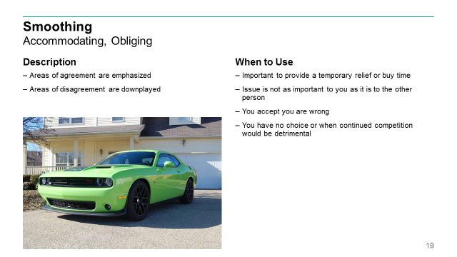

<CLICK> Next we have Smoothing which is also referred to as accommodating or obliging. In this approach, the <CLICK> areas of agreement are emphasized and the <CLICK> areas of disagreement are downplayed. The approach emphasizes cooperation instead of assertiveness. A person places his interest last and allows the other party to further their interests. The accommodating approach often occurs when a party is not significantly invested in securing a victory, because they do not perceive the alternative option as a significant threat.

Simply put, smoothing is accommodating the concerns of other people first of all, rather than one’s own concerns. This technique emphasizes agreement rather than differences of opinion.

Here’s an analogy to explain what smoothing is: When I am driving in traffic, I often see somebody who is playing a zero-sum game, for whom the object is to get ahead of you, at all costs, whether you actually have the right-of-way or not. If I have the right-of-way and I detect that the person is being an aggressive driver, then I will slow down and let the person take “pole position” because in reality, I am not playing the same game as the other driver. I am playing the game where the object is not to get ahead of the driver in front of me, but to keep the traffic flowing smoothly. Today this may require me to sacrifice the position that is “rightfully” mine; the next day however, the driver next to me may wave me ahead in a gesture of courtesy. It’s all good – because it contributes to the flow of traffic, whereas playing the traffic game like outtakes of the Fast and Furious can land one in a hospital – or worse!

<CLICK> What are some examples of times when you want to use the smoothing approach? Well first is when it is <CLICK> important to provide a temporary relief from the conflict or buy time until you are in a better position to respond or push back. As a general rule, smoothing will bring quick results and there are times where that is what is needed right at the moment until you have time to go back and use a more intensive approach that will look at all the alternatives.

Another example would be, <CLICK> when the issue is not as important to you as it is to the other person. Go back to the analogy I used a moment ago: that other driver just has to get right in front of me. I know that we are probably going to get where we are going about the same time if I’m in front or he is in front. Plus, in all honesty; as soon as the road opens up, there is no way the guy in is Prius is going to keep up with me <CLICK>. And yes, that is my daily driver.

Another example of when smoothing may be appropriate is <CLICK> when you accept you are wrong. There is a saying that goes: sometimes you have to shut up, swallow your pride, and accept that you’re wrong. It’s not giving up, it’s called growing up. So when as a leader you know you are wrong, use the smoothing approach to get the conflict resolved and get moving on to probably more important things.

One more example of an appropriate time to use smoothing is <CLICK> when you have no choice or when continued competition would be detrimental. Again, there are a lot of times when it’s just easier to get the conflict resolved and back to what’s important – getting work done.

# Slide 20

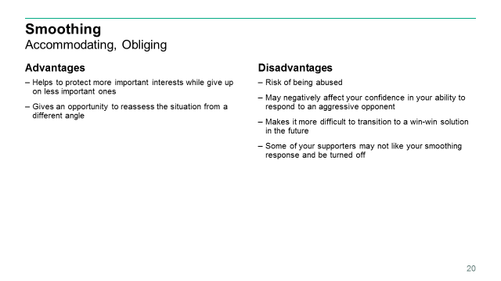

So what are the <CLICK> advantages to the Smoothing approach to conflict resolution; well first is that <CLICK> in some cases smoothing will help to protect more important interests while giving up on some less important ones. Look, smoothing is a Lose/Win approach – someone or something is going to lose something. But if what is being lost is of less importance than what is gained, then there is a big benefit to gaining that big advantage. Go back to my driving analogy. It is not that important whether I’m first in the line of cars or second; but what is more important is that there isn’t an accident. By using the smoothing approach, I have gain a much more important interest – not getting into an accident.

Another advantage is that <CLICK> smoothing give an opportunity to reassess the situation from a different angle. This is especially true when you are resolving a conflict that you are directly involved in. By basically giving up what I wanted and letting the other get what they want, you will be in a good position to see the situation from the other person’s view.

But there are some <CLICK> disadvantages to the smoothing approach. First off, there is <CLICK> the risk to be abused. The opponent may constantly try to take advantage of your tendency toward smoothing. Therefore it is important to keep the right balance and this requires some skill. I do not want to downplay the use of the smoothing approach – as a people manager I use it as a way to keep people satisfied with their work. But I know that if I was to simply just use smoothing that people are going to abuse me and get more than they deserve. So you have to use care about on often you use this approach.

Along the same lines, <CLICK> the smoothing approach may negatively affect your confidence in your ability to respond to an aggressive opponent. If you have that hardnosed guy in the office who pushes his way through everything, the excessive use of the smoothing approach can have negative results on you as you will have a hard time using a more intensive approach as you have your confidence blown.

The smoothing approach can <CLICK> make it more difficult to transition to a win-win solution in the future. While not always possible, I think we all wish we could get to a win-win solution but the smoothing approach provides a lose-win solution – someone has to “lose” in order for the smoothing approach to be successful. So let’s say you used the smoothing approach to get a temporary peaceful solution in order to get work done with the thought that after a major deadline you’ll go back and work on a win-win solution using maybe the collaborating approach. Or maybe you realize that what is better is a lose/lose solution because in the end that is what is better for the team so you what to try to use the compromise approach. Well once one side has won, it will be that much hard to get them back to the table and possibility “lose” what they have already have “won.”

One more disadvantage to the smoothing approach is that <CLICK> some of your supporters may not like your smoothing response and be turned off. This is something I have seen firsthand. As a program manager I work on disagreements day in and day out. There will be times where I will use the smoothing approach – generally because I need a quick solution so the team can get back to what’s important – and I will see where others not involved in the conflict do not like my response. This is especially true for my project managers as even though they might not had a vested interest in the conflict, they might not like that someone won while someone lost. Or more importantly, they might not like the fact of WHO won. Now when this does happen, you have to work it out with these supporters so that they understand why you went down one path instead of another.

# Slide 21

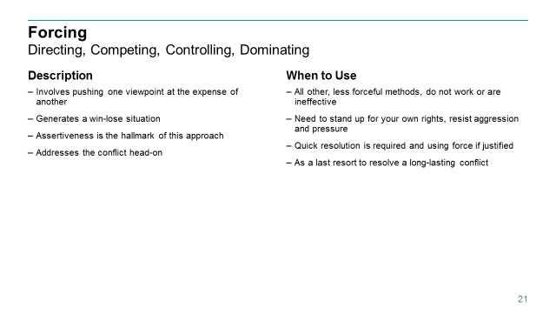

The next approach we are going to look at is <CLICK> Forcing, which is also known as directing, competing, controlling, or dominating. This technique <CLICK> involves pushing one viewpoint at the expense of another and will <CLICK> generate a win-lose situation. When using this approach, an individual firmly pursues his or her own concerns despite the resistance of the other person. <CLICK> Assertiveness is the hallmark of this approach, and those employing this approach aim to <CLICK> address the conflict head-on. It might involve high levels of emotions as the parties establish positions in what can sometimes evolve into hostile communications.

<CLICK> So when are sometimes when you will use the forcing approach: Well the obvious time is when <CLICK> all other, less forceful methods, do not work or are ineffective. So if you have been working long on hard on getting collaborating, compromising, or even smoothing to work with no luck then you are probably going to have to resort to using the Forcing approach in order to get the conflict resolved and people back working.

Another time to use the forcing approach is when <CLICK> you need to stand up for your own rights and resist aggression and pressure from others. As leaders, there are just times when we need to assert our professional needs over others. Generally you have become a leader because you a trusted professional and you have earned the right and have the experience to be right. But be careful when using this approach when standing up for yourself as perception can quickly change and you are viewed as a dictator.

A third reason to use the forcing approach is when <CLICK> a quick resolution is required and using force is justified. For example, you might use the forcing approach in a life-threatening situation or to stop an aggression. Working within a federal facility – more importantly, the headquarters for Army human resources where they make decisions that sometimes does not make trained soldiers happy – we go through active shooter training at least annually. Part of that training is making the decision on what to do if an active shooter enters the area. Amongst the possibilities is taking out the shooter. In a way, this is an example of the forcing approach to conflict resolution since you your concerns are the safety of yourself and those around you instead of whatever the shooter is out for. Using the forcing approach can be an appropriate response to that conflict since it will *hopefully* end a life-threatening situation.

Yet another example of when it might be appropriate to use the forcing approach is <CLICK> as a last resort to resolve a long-lasting conflict. Maybe you have entered a conflict that has been going on a long time and if that conflict continues it could be detrimental to the project or people’s well beings. Well then maybe you just need to start with the forcing approach to resolve that conflict that has been going on for a long time.

# Slide 22

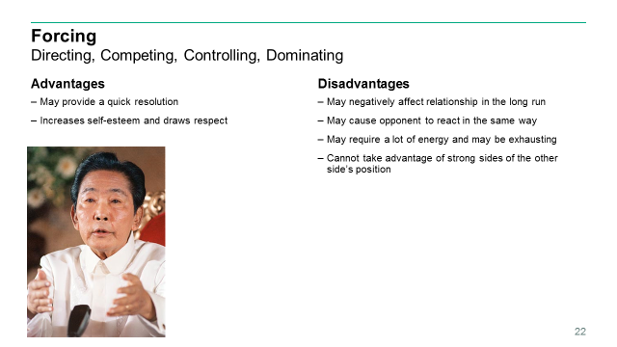

As with the other conflict resolution approaches, there are advantages and disadvantages to using the forcing approach. First, it <CLICK> may provide a quick resolution to a conflict. There is not a lot of back and forth discussion from the different sides – actually there might not be any discussion – so this approach has a tendency to generate results pretty quickly.

Another advantage is that <CLICK> it will increase self-esteem and draws respect when the action is a response to an aggression or hostility. The self-esteem part is obvious since the one using the technique is getting what they want. But you might be saying to me that even if you get some respect by using this approach, that respect is probably short lived. Well that can be the case, but not always.

A great example is <CLICK> Ferdinand Marcos. Depending on your age and assuming you have never been related to a Filipino, you probably know Ferdinand Marcos as the Filipino dictator that was deposed after a people uprising that forced him to exile to Hawaii with his wife leaving behind over a 1000 pairs of shoes but bringing billions of dollars from the Philippine coffers. Well let me provide a little bit more history and context.

Marcos became the president of the Philippines in 1965 and reelected in 1969 as the first Filipino president to serve a second term. 1970 was a period of unrest in the Philippines, composed of a series of heavy demonstrations, protests, and marches against the government from January to March 1970. These protests became a factor leading to the declaration of Martial Law in 1972 which ran through 1981. Marcos had a vision of what he called the New Society; similar to Indonesia’s New Order administration. He used the years of martial law to implement this vision. According to Marco’s book *Notes on the New Society*, it was a movement urging the poor and the privilege to work as one for the common goals of society and to achieve the liberation of the Filipino people through self-realization. During his martial law regime, Marcos confiscated and appropriated by force and duress many businesses and institutions, both private and public.

You would think that the Filipino people would have been upset after that many years of martial law, but many saw him as a powerful man who got things done. So much so that in 1981, Marco ran and won a massive victory over the other candidates in the first presidential election in twelve years. Now while I’m trying to demonstrate an advantage of using the forcing approach, there is a disadvantage as the people tired of the corruption and in 1986 there was a People Power movement which caused Marcos to flee the country and Corazon Aquino became president.

But here is the thing. After new administrations came in and tried to clean up the corruption, they did not have the ability to pull off all the great infrastructure projects and other things Marcos did that kept people happy. And just 10 years later you would hear from Filipinos that they were happier under Macros. Back in February of this year, the New York Times ran an article entitled *30 Years After Revolution, Some Filipinos Yearn for ‘Golden Age’ of Marcos*. The article included a quote from a Filipino who was born two years after Macros was overthrown and he said, “I think Marcos was our best president; that was when the Philippines was the leader of Asia. We were respected.”

Now I’m not proposing you become a dictator, but there are times when the forcing approach has its purpose and it can get respect from others.

What about <CLICK> disadvantages? Well there are plenty and they are heavy costs. First off, using the forcing approach may <CLICK> negatively affect your relationship with the opponent in the long run. Just like in my example with President Marcos, he continued to use the forcing approach and it caused strife amongst the people to the point that there was public demonstrations and the city of Manila was overrun by opposition. You have to be careful when using this approach to not become a dictator.

Another disadvantage is that <CLICK> it may cause the opponent to react in the same way, even if the opponent did not intend to be forceful originally. There is the concept of the flight-or-fight response which is a physiological reaction that occurs in response to a perceived harmful event, attack, or threat to survival. While some might fly away from future conflict, others will see this a threat to their survival and might retaliate back using the same approach to you.

Along with these disadvantages, using the forcing approach <CLICK> may require a lot of energy and be exhausting to some individuals. Look it can be a whole lot easier to use something like the smoothing approach to resolve conflict. Because there can be some resistance – at least at first – this can be tiring to the one enacting the technique.

The last disadvantage I want to look at is actually more important in my mind. Using the forcing approach <CLICK> does not take advantage of the strong sides of the other side’s position. You are probably not even listening at what the other side has to say. And if you do, you are not taking any advantage of their solutions.

# Slide 23

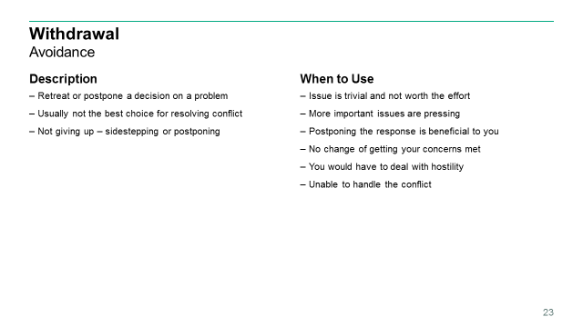

Finally we have the <CLICK> Withdrawal approach, which is also known as avoidance. In this technique, the parties <CLICK> retreat or postpone a decision on a problem. <CLICK> Dealing with problems is a PMI-ism; therefore, withdrawal is not usually not the best choice for resolving conflict, though there may situations where it is necessary. <CLICK> Note that this not giving up, it’s just sidestepping or postponing the issue.

When are times you would employ the Withdrawal approach? <CLICK> Well there are more times than you would think and I’m not including because you are lazy – which would be a bad reason to withdrawal from a conflict.

But first there is when <CLICK> the issue is trivial and not worth the effort. Conflicts come in all shapes and sizes and there are those that will not warrant your attention. Along the same lines, another time withdrawing may be appropriate is <CLICK> when more important issues are pressing and you do not have time to deal with it. Again, if you are a leader of some sort, then you live a busy life and just do not have time to get into every little conflict.

Another good time to look at using the withdrawal approach is <CLICK> in situations where postponing the response is beneficial to you. For example, it might not be the right time or place to confront the issue or you need more time to think and collect information before you act. This is actually a pretty common use of the withdrawal – or at least it should be. I use an example from my program. We have an application that has traded hands several times over and has been just below importance of other applications. As such, it has some technical issues and debt that we need to address. Some of the new folks on the team wanted to address these issues right in the middle of a release where we are trending on time but just barely. Obviously addressing these at the moment would mean we would go over schedule and that is not beneficial to me or my team. Plus I was hearing comments like whoever built this had no clue what they were doing. I had to remind these new folks that one it is easier to see better ways to build something after it has already been built and two we are the ones that built it to begin with. My primary focus is ensuring that the customer is happy with the service my team is providing and I do not want the customer thinking we built them a bad thing – even if it was built before I moved on the team. So I got my team to withdraw from the issue and we’ll readdress it later when it’s more appropriate.

Another possibility would be <CLICK> when you see no chance of getting your concerns met or you would have to put forth unreasonable efforts.

<CLICK> There are times when the appropriate solution would cause hostility and you need to avoid that, so using the withdrawal approach would make sense there.

Finally, using the withdrawal approach may be appropriate when <CLICK> you are unable to handle the conflict such as when you are too emotionally involved or another can handle it better. Look, if you are emotionally involved in a situation, then it’s probably better to take a step back and let someone else come in.

# Slide 24

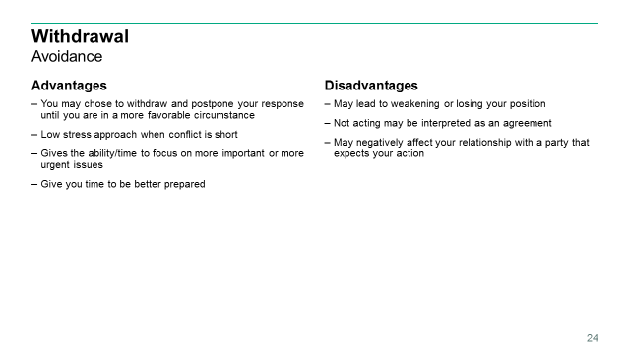

So what are the <CLICK> advantages to using the Withdrawal approach? First, <CLICK> when the opponent is forcing or attempting aggression, you may choose to withdraw and postpone your response until you are in a more favorable circumstance for you to push back. Quite often we will see aggressive action taken against us and we fight back. But maybe the right call is to withdraw which will give us the opportunity to come back when you have a better chance of getting what you need.

<CLICK> Withdrawing is a low stress approach when the conflict is short. There are times when we see that the conflict is going to be a short one; so instead of creating a bunch of stress trying to solve the conflict, the withdrawal approach provides a way to lower the stress all around.

Also the withdrawal approach < CLICK > gives the ability and time to focus on more important or more urgent issues instead. Like I have said, you will have all sorts of conflicts come your way and they do not all deserve the same level of attention.

And the withdrawal approach <CLICK> gives you time to better prepare and collect information before you act.

So what about <CLICK> disadvantages? The biggest is that <CLICK> using this technique may lead to weakening or losing your position; not acting may be interpreted as an agreement. Using withdrawing strategies without negatively affecting your own position requires certain skill and experience. You do not want to be considered weak, as you will no longer be a leader.

Also <CLICK> when multiple parties are involved, withdrawing may negatively affect your relationship with a party that expects your action. In my role, I see conflicts between developers and project managers and there are times where if I do not act – even though it might be in mine or the team’s best interest – it can cause one of those sides to feel slighted by my “lack” of action.

# Slide 25

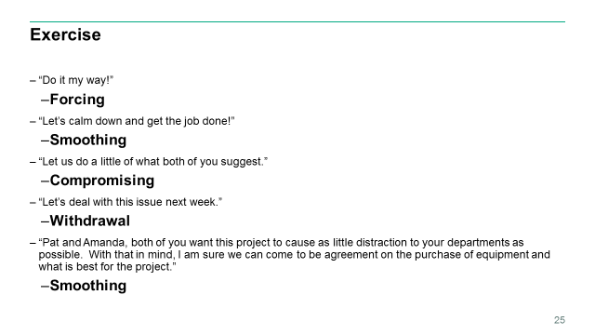

Let’s have a quick exercise and see how well you picked up these different approaches. We’ll look at some descriptions of conflict resolution and you’ll try to determine which of these techniques is being used.

<CLICK> Do it my way!

<CLICK> Obviously this is an example of the Forcing approach.

<CLICK> Let’s calm down and get the job done!

<CLICK> Here is an example of the Smoothing approach.

<CLICK> Let’s do a little of what both of you suggest.

<CLICK> That’s pretty much the definition of what the Compromising approach is.

<CLICK> Let’s deal with this issue next week.

<CLICK> That would be Withdrawal.

<CLICK> Pat and Amanda, both of you want this project to cause as little distraction to your departments as possible. With that in mind, I am sure we can come to be agreement on the purchase of equipment and what is best for the project.

<CLICK> This would be Smoothing

# Slide 26

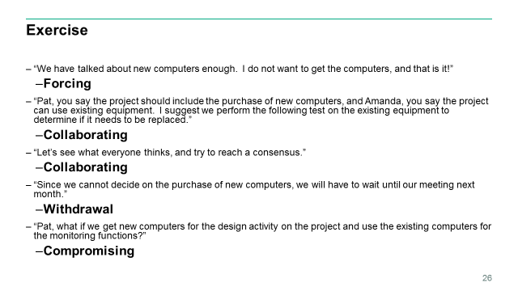

<CLICK> We have talked about new computers enough. I do not want to get the computers, and that is it!

<CLICK> Here is another example of Forcing.

<CLICK> Pat, you say the project should include the purchase of new computers, and Amanda, you say the project can use existing equipment. I suggest we perform the following test on the existing equipment to determine if it needs to be replaced.

<CLICK> Here we have Collaborating.

<CLICK> Let’s see what everyone thinks, and try to reach a consensus.

<CLICK> Here is another example of Collaborating.

<CLICK> Since we cannot decide on the purchase of new computers, we will have to wait until our meeting next month.

<CLICK> Here the team is putting off a decision, so this would be Withdrawal.

<CLICK> Pat, what if we get new computers for the design activity on the project and use the existing computers for the monitoring functions.

<CLICK> Here the manager has found a way that will somewhat satisfy both sides, so this would be Compromising.

# Slide 27

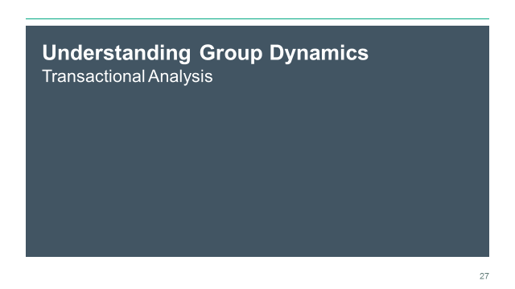

<CLICK> Now that we have an understanding of the common approaches to conflict management, let’s look at some group dynamics. It is pretty hard to resolve conflict amongst multiple groups of people if you do not have a general understanding of how people work and how group dynamics work.

Transactional analysis is a psychoanalytic therapy wherein social transactions are analyzed to determine the ego state of the patient as a basis for understanding behavior. In transactional analysis, the patient is taught to alter the ego state as a way to solve emotional problems. The method deviates from Freudian psychoanalysis which focuses on increasing awareness of the contents of unconsciously held ideas. Eric Berne developed the concept and paradigm of transactional analysis in the late 1950s.

We are not going to go down a long path of how to psychoanalyze your team, but there is an important tool within transactional analysis that is useful when working with conflict resolution and we are going to talk about that. <CLICK>

# Slide 28

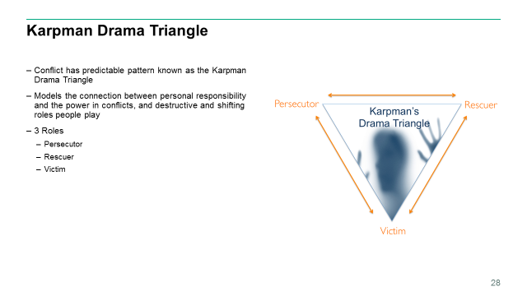

Conflict has a predictable pattern known as the drama triangle which was first introduced by Dr. Steven Karpman. The basic concept underpinning the Karpman Drama Triangle is the connection between responsibility and power, and the destructive and shifting roles people play.

<CLICK> He defined three roles in conflict: Persecutor, Rescuer, and Victim.

<CLICK> Dr. Karpman placed these three roles on an inverted triangle and referred to them as being the three aspects, or faces of drama. He had interests in acting and chose the term “drama triangle” rather than the term “conflict triangle” as the Victim in his model is not intended to represent an actual victim, but rather someone feeling or acting like a victim.

<CLICK>

# Slide 29

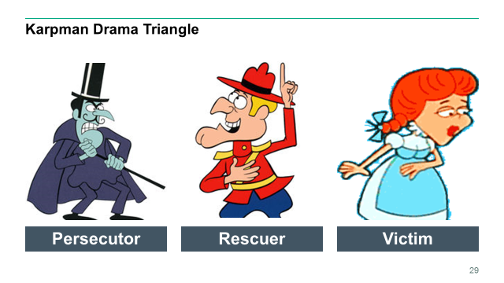

So let’s take a quick look at these roles:

<CLICK> The Persecutor insists, “It’s all your fault.” The Persecutor is controlling, blaming, critical, oppressive, angry, authoritative, rigid, and superior.

<CLICK> The Rescuer’s line is “Let me help you.” A classic enabler, the Rescuer feels guilty if they do not go to the rescue. Yet their rescuing has negative effects as it keeps the Victim dependent and gives the Victim permission to fail. The rewards derived from this rescue role are that the focus is taken off of the rescuer. When they focus their energy on someone else, it enables them to ignore their own anxiety and issues. This rescuer role is also very pivotal, because their actual primary interests is really an avoidance of their own problems disguised as concern for the victim’s needs.

<CLICK> The Victim’s stance is “Poor is me!” The Victim feels victimized, oppressed, helpless, hopeless, powerless, ashamed, and seems unable to make decisions, solve problems, take pleasure in life, or achieve insight. The Victim, if not being persecuted, will seek out a Persecutor and also a Rescuer who will save the day but also perpetuate the Victim’s negative feelings.

Initially, a drama triangle arises when a person takes on the role of a victim or persecutor. This person then feels the need to enlist other players into the conflict. These enlisted players take on roles of their own that are not static, and therefore various scenarios can occur. For example, the victim might turn on the rescuer, the rescuer then switches to persecuting – or as often happens, a rescuer in encouraged to enter the situation.

The motivations for each participant and the reason the situation endures is that each gets their unspoken and often unconscious psychological wishes and needs met in a manner they feel justified, without having to acknowledge the broader dysfunctional or harm done in the situation as a whole. As such, each participant is acting upon their own selfish needs, rather than acting in a genuinely responsible or altruistic manner. Thus a character might ordinarily come on like a plaintive victim; it is now clear that they can switch into the role of Persecutor providing it is “accidental” and they apologize for it.

The motivations of the rescuer are the least obvious. In the terms of the drama triangle, the rescuer is someone who has a mixed or covert motive and is actually benefiting their ego in some way from being “the one who rescues.” The rescuer has a surface motive of resolving the problem, and appears to make great efforts to solve it, but also has a hidden motive to not succeed, or to succeed in a way that they benefit. For example, they may get a self-esteem boost or receive respected rescue status, or derive enjoyment by having someone depend on them and trust them – and act in a way that ostensibly seems to be trying to help, but at a deeper level plays upon the victim in order to continue getting a payoff.

In some cases, the relationship between the victim and rescuer can be one of codependency. The rescuer keeps the victim dependent on them by encouraging their victimhood. The victim gets their needs met by having the rescuer take care of them. <CLICK>

# Slide 30

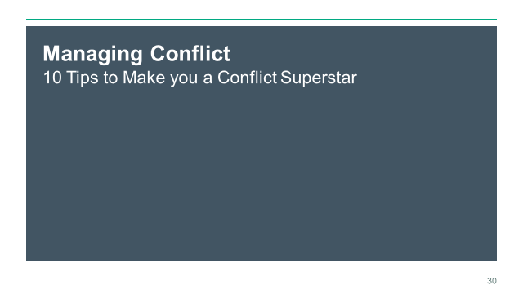

Now that we have given an overview of what conflict and conflict resolution is, talked about the 5 primary approaches to conflict resolution, and about the group dynamics within a conflict; let’s cover some tips that will make you a superstar when it comes to resolving conflict.

# Slide 31

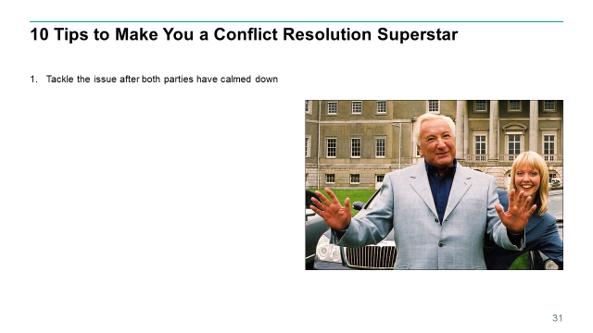

<CLICK> First, tackle the issue after both parties have called down. What is the absolute worst time to try to get all sides of a conflict to think rationally about something – right as everything is blowing up? You want to address the issue early, before it turns into a bigger problem, but be sure to wait until things have cooled down. It is difficult to have a productive discussion if those involved are angry or upset. Wait until everyone is clear-headed. Maybe that means taking a 10 minute break, breaking for lunch, or scheduling a spate meeting. But whatever it is, give everyone a chance to cool off.

# Slide 32

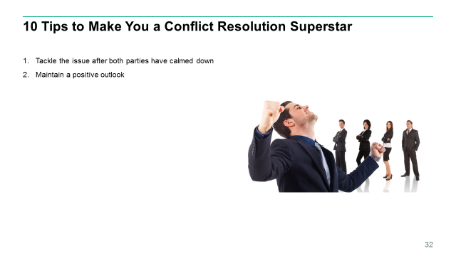

<CLICK> Maintain a positive outlook. Do not enter assume the other party is hostile or unwilling to work out a solution. If you are entering the conversation with negative expectations, you may unwittingly elicit the very reactions you are trying to avoid. Keep an open mind throughout, and try not to assume that the other parties will be unreceptive to your concerns. Try talking directly with the person you are having the conflict with. Meet in a neutral place, remain calm, and treat the other person with respect.

If you a manager or leader dealing with conflict amongst your team, this is even more important. If the team sees you do not have a positive feeling that the conflict will be beneficial to the team as a whole, then their hearts will not be in it.

# Slide 33

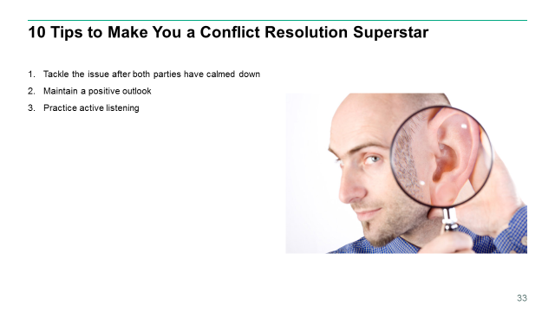

<CLICK> Practice active listening. When you approach another party about something you do not agree about, do not just fire off concerns. Hear them out. Pay attention, ask questions, try to understand the other group’s perspective, and acknowledge the emotions that all sides are experiencing. When discussing the conflict, focus on the behaviors needed for resolution. This will keep the discussion focused on the issue or problem, rather than turning it into a personality clash that may further escalate the conflict.

# Slide 34

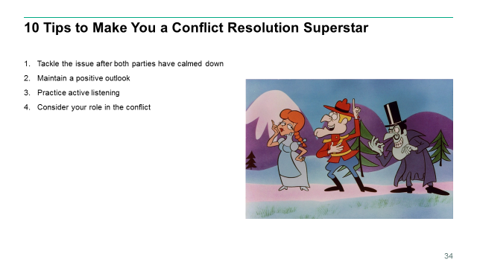

<CLICK> Consider your role in the conflict. So where do you fit in to the conflict. Did you start something you probably did not mean? Of even if you meant it, maybe you shouldn’t have started it anyways. Maybe you are the victim, you just wanted to get your work peer reviewed and that started a holy war of whether the team should be using spaces or tabs. Or just maybe you came in to be the rescuer – and that can be good or bad depending on the purpose of the rescue

Understanding where you fit in the conflict will take you further down the path of how to resolve the issue.

# Slide 35

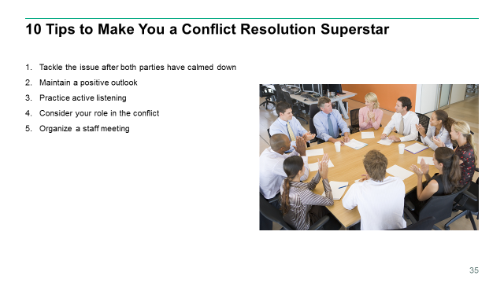

Let’s think about the peer review example I just said. Let’s assume you have two developers performing a peer review at one of their desks and an all-out battle ensues about whether to use tabs or spaces in their code. And for the non-developers in the room, that really does happen; although not as often as it used to. As a project manager you hear what’s going on and you can see that this is just going to get worse. Well why not pull everyone into a collaboration room and discuss it. You probably will advert a real conflict quickly, meaning that it will probably be worth a few moments that to have these two developers mad for the rest of the day.

# Slide 36

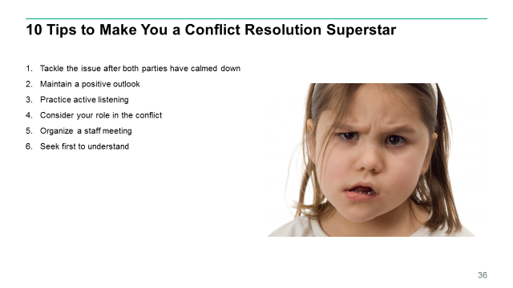

<CLICK> Seek first to understand. Try not to jump to conclusions. May conflicts originate as simple misunderstandings, misinterpretations, and missed opportunities to clarify another’s intentions. You can mitigate or altogether avoid so many of your daily conflicts by simply seeking first to understand those with whom you interact with. While simple, however, this mindset is not common or even encouraged in our fast-paced workplaces. Workers can illuminate their understanding of a conflict by honing their listening skills, asking clarifying questions, and earnestly seeking other’s underlying interests. This simple action not only stops its escalation; it opens the doors for early and lasting resolutions as well.

# Slide 37

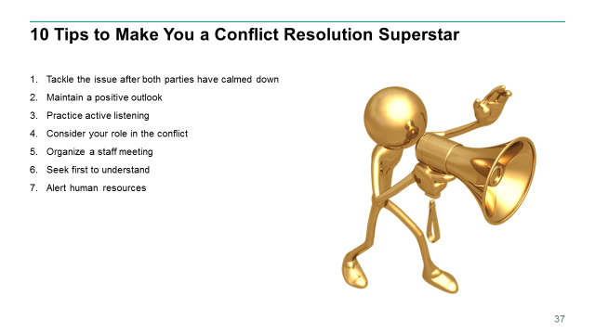

<CLICK> Alter human resources. If you are battling an issue as serious as workplace harassment, the problem might require intervention from someone higher up. When direct attempts and mediation are not effective, you may have to pursue formal channels. Talk to your supervisor and human resources and follow your organization’s formal procedures for filing a complaint. Document the problem in writing, being specific about what behaviors occurred, when they happened, what impact they had, and what needs to be done to resolve conflict.

Really simple; no matter what level you are, you do not want to go it alone when it comes to workplace harassment. Doing so will just cause you more grief than you would ever want.

# Slide 38

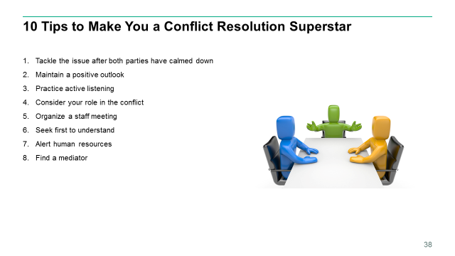

<CLICK> Find a mediator. Some workplace clashes turn into intractable battles worthy of a war movie. If you find yourself locked into a fight, it may be time for the groups to bring in a mediator.

You can introduce the conflict to a mediator formally or informally. An informal meeting with an objective person who all sides respect can help you talk through problems without the formalities (and potential subsequent consequences) of a formal mediation.

If an informal meeting does not put the issue to rest, you may need to contact a supervisor for help in resolving the conflict. If you choose a formal mediation, be sure to be on your best professional behavior. Do not attack your opponent. Present the conflict in objective terms and not as an emotional reaction to someone who happens to have an opposing viewpoint.

In a formal mediation, expect enlightenment. A third-party observer may be quick to point out failings in your argument that you just could not accept from a co-worker. And that is the beauty mediation – it helps being the conflict to an objective, level playing field that is fairer for everyone.

# Slide 39

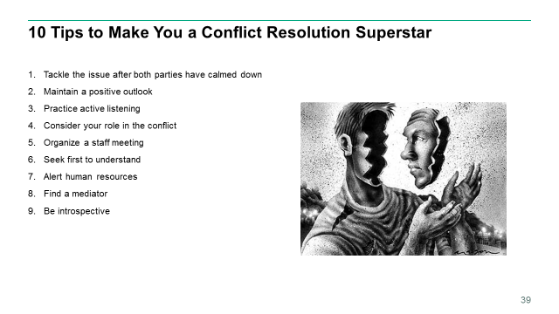

<CLICK> Be introspective. Conflicts arise in every workplace, and personality clashes abound in all of them. Conflict is inevitable – plan for the future. In the aftermath of a conflict at work, take some time to consider how you manage your emotions. How do you experience stress or anger? What triggers set you off? How do you tend to react in the face of conflict? What coping skills do you use? Are they healthy ones? Use this self-awareness to make a plan for handling conflict better the next time one arises.

Each conflict is an opportunity for growth. Therefore, you should reflect and readjust after one occurs. Conflicts provide the opportunities to better appreciate another perspective, clarify your own interests, strengthen bonds, and discover new ways forward. Internalizing these experiences and growing from them allows you to face tomorrow’s difficulties with greater ease and effectiveness.

And honestly, this tip applies to life in general. Every workday morning I wake up and no one else is up. I get ready in complete silence. I then drive my 35-mile commute by myself. During this time, I think about what went on the previous day. What did I do right and what can I do better. Is there something I need to jump on as soon as I get in to correct a mistake the previous day? I think about all this each morning and I get into the office with a plan how to handle that day.

# Slide 40

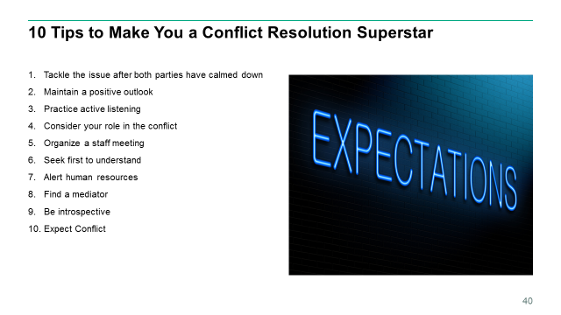

<CLICK> Finally, expect conflict. A conflict-free workplace would be a beautiful place indeed. However, it is just not possible to avoid conflict entirely. You have to learn to expect that conflict will become a part of your work life at some point.

The real imperative is learning to deal with conflict in a productive way. Do not let disagreements gather momentum and turn into major crises. Instead, address them as soon as possible. Resolve them instead of letting them fester.

Of course, for many people, avoidance or passive-aggressiveness is a more course of action. But fearing or avoiding conflict tends to make edgy situations much worse.

As you work to manage the problem, make sure that the conflict is totally resolved for all sides. If you feel triumphant but you co-worker is deflated and upset or convinced that the outcome was unfair, there is a good possibility that the problem will flare up again. Learn better communication skills, though, and you will be a better overall employee and a happier person.

# Slide 41

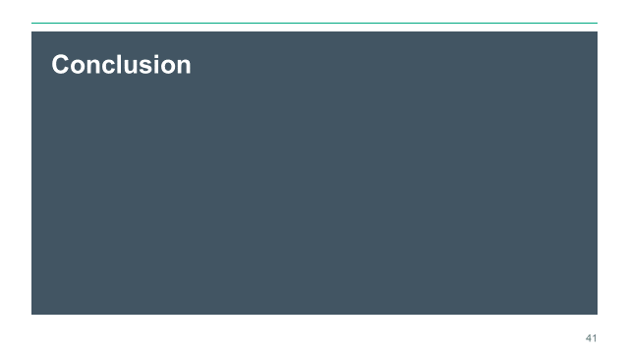

<CLICK> So in conclusion, conflict in project management is not necessarily unfavorable when properly managed. Several advantages have been identified such as increasing personal growth and moral, enhancing communication, and producing better project outcomes. However, conflict can be the decline of an organization if it is not effectively managed. The challenge for organizational leaders and project managers is to try to maintain the right balance and intensity of conflict in project management. By utilizing project management principles, understanding the dynamics of conflict, and leaning approaches to conflict resolution, leaders will be able to establish an environment in which creativity and innovation is encouraged and project goals are accomplished.

# Slide 42

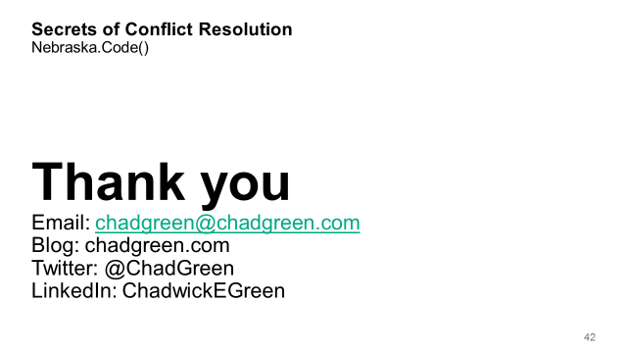

Any questions?

Thank you for letting me talk to you for the past hour. I will be relaunching my blog very soon which include copies of these slides. Just email me if you would like them before that. Hopefully you enjoy the rest of your time at Nebraksa.Code()